Cargo identification label:
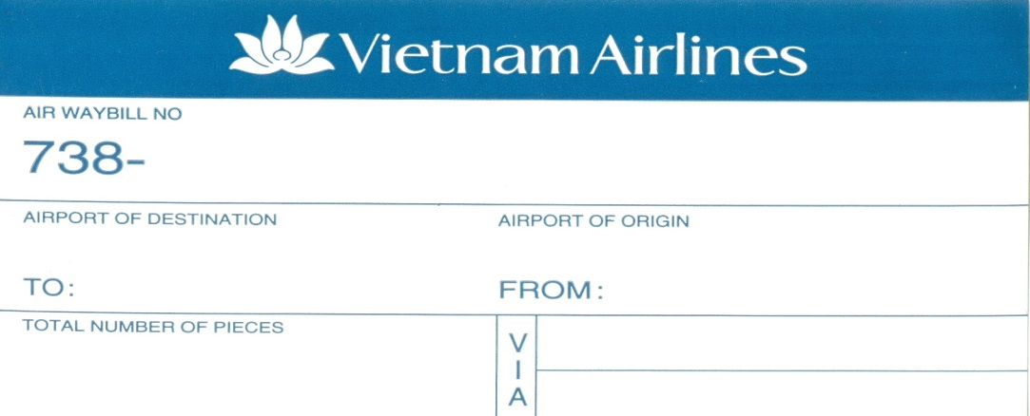
Perishable label:

